Christian Wendlandt

Professor George Thomas

Computer Science 361

29 March 2018

Assignment 2 Diagram

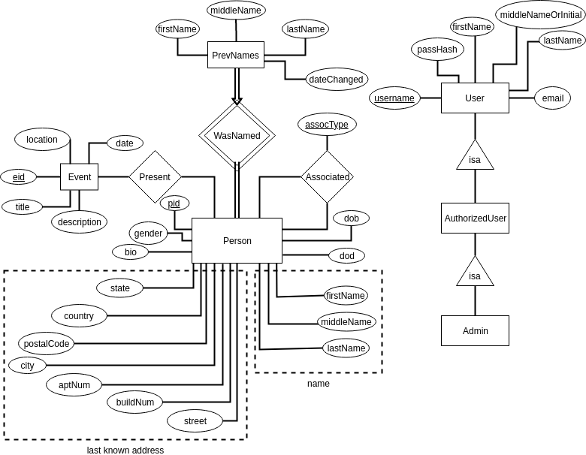

Change Log:

* Added name attributes to Person.
* Changed Names entity into PrevNames entity; isCurrent was no longer necessary.
* Added dateChanged attribute to PrevNames.
* Added dob (date of birth) and dod (date of death) attributes to Person.
* Expanded name attribute in User into firstName, middleNameOrInitial, and lastName.